Development environment

🗂️ What Is Development environment?
# Source: AI Source: Provided by: [Data Path: Persons Table -> ID Column: 1, Name_En Column: Motasem Essam] -> From: [ChatGPT] on [1/26/2026]
Development environment is the setup where developers build, run, and test code while creating it.
It’s basically the app’s workshop, not the showroom.
What “Development” means
The development environment is optimized for:
- Writing code
- Debugging errors
- Fast feedback
- Experimentation (breaking things is OK here)

Typical characteristics
# Source: AI Source: Provided by: [Data Path: Persons Table -> ID Column: 1, Name_En Column: Motasem Essam] -> From: [ChatGPT] on [1/26/2026]
In a development environment, you’ll usually find:
- 🧑‍💻 Runs on a local machine (laptop/PC)
- 🐞 Debug mode ON (detailed error messages, logs)
- 🔁 Hot reload / auto-restart when code changes
- 🗄️ Local or test databases
- 🔐 Fake or test credentials (never real secrets)
- ⚡ Lower performance & security requirements

Example configuration
# Source: AI Source: Provided by: [Data Path: Persons Table -> ID Column: 1, Name_En Column: Motasem Essam] -> From: [ChatGPT] on [1/26/2026]
ENV=development
DEBUG=true
DATABASE_URL=localhost
LOG_LEVEL=verbose

What it’s used for
# Source: AI Source: Provided by: [Data Path: Persons Table -> ID Column: 1, Name_En Column: Motasem Essam] -> From: [ChatGPT] on [1/26/2026]
- Developing new features
- Fixing bugs
- Trying ideas safely
- Writing and running unit tests

How it compares to others
# Source: AI Source: Provided by: [Data Path: Persons Table -> ID Column: 1, Name_En Column: Motasem Essam] -> From: [ChatGPT] on [1/26/2026]
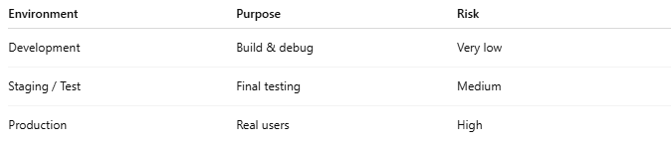
Environment | Purpose | Risk
Development | Build & debug | Very low
Staging / Test | Final testing | Medium
Production | Real users | High

Real-world analogy
# Source: AI Source: Provided by: [Data Path: Persons Table -> ID Column: 1, Name_En Column: Motasem Essam] -> From: [ChatGPT] on [1/26/2026]
Think of it like:
A practice kitchen where chefs test recipes
Messy, loud, experimental — but safe.

